Air Brake System Warning Chime – 2020 H567/Heavy Truck Specific CGEA 1.3

Functional Description

The purpose of the Air Brake Warning Chime is to Alert the driver of a loss in pressure with the air brake system that may result in automatic application of the park brakes to stop the vehicle. Although technically not required with the red brake telltale being in the drivers forward field of vision (reference FMVSS 121 S.5.1.5) we chose to implement the continuous chime as it is an expected feature in the market place. Currently the only Ford vehicle requiring this function is H567. This STSS v1.0 is released for the 2020 H567 which is transitioning to CGEA1.3.

The Air Brake System Warning Chime feature correlates the operational mode and the AirChrgLoLampOn_B_Rq signal to request the chime arbitrator to sound a continuous audible warning.

The Air Brake System Warning Chime uses a continuous chime as defined in the Chime Arbitrator Section.

Interfaces

Interface Context Diagram (I/O Block Diagram)
Figure 1.1 Air Brake System Warning Chime Context Diagram
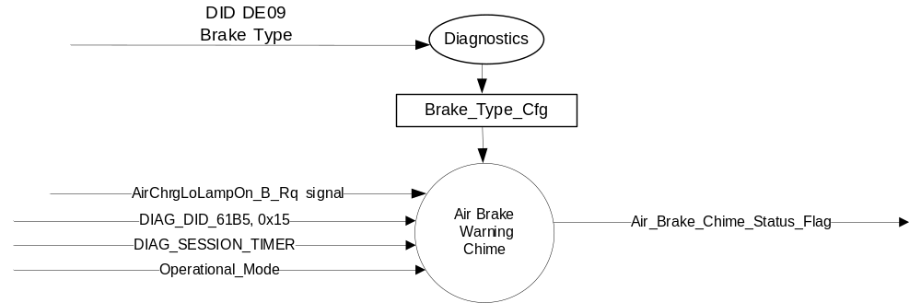

Inputs

- INTERNAL:
- Operational Modes: refer to section Operational Modes
- DIAG_DID_61B5, 0x15
- DIAG_SESSION_TIMER
- MUX message on the HS_CAN Bus from the GFM_ATM.

- AirChrgLoLampOn_B_Rq Signal
Signal Name | Size  (bits) | Detail | Units | Res. | Offset | State  Encoded | Min. | Max.
AirChrgLoLampOn_B_Rq | 1 |  | SED | 1 | 0 |  | 0(0x0) | 1(0x1)
AirChrgLoLampOn_B_Rq |  | Off |  |  |  | 0x0
AirChrgLoLampOn_B_Rq |  | On |  |  |  | 0x1

Outputs
- Air_Brake_Chime_Status_Flag

Function/Performance

Operational Modes

Mode | Differentiating Vehicle Conditions
Sleep Mode | Air Brake System Warning Chime OFF
Limiting Mode | Air Brake System Warning Chime OFF
Normal Mode | Air Brake System Warning Chime ON / OFF
Crank Mode | Air Brake System Warning Chime OFF

Voltage Levels

Refer to the Cluster Features Table located in the Operational Modes and Voltage Range Strategies Secion of this SPSS.

Human-Machine Interface

Visual

None

Audio

Continuous chime as defined in the Chime Arbitrator Section.

Switch Control Logic

Not Applicable.

System Accuracy

- The state of this chime shall change within 100 msec of a state change
- Refer to System Accuracy in the Chimes & Chime Arbitrator SPSS section

Operation: Performance and Functional

Subsystem Algorithm Flowchart / State Diagram
Table 1.2 Air Brake System Warning Chime State Matrix Table
Operational Mode | Brake  _Type_Cfg | DIAG_  SESSION_  TIMER | DIAG_DID_  61B5 | AirChrgLoLampOn  _B_Rq Signal | Air_Brake_Chime  _Status_Flag
Normal or Crank | Air Brake | Not Active | X | On (0x1) | Active
Normal or Crank | Air Brake | Active | Not Received | On (0x1) | Active
Normal or Crank | Air Brake | Active | Air Brake Warning Chime (0x15) | x | Active
All Other Cases |  |  |  |  | Inactive
X = Don’t Care
Not Received = The state when a DIAG_SESSION_TIMER is active and the DID has not been received
Chime unit always starts with ON and must complete one full ON / OFF cycle consistent with other chimes in the referenced chime arbitration specification

Function Safety Classification (EMC) On

Class B

Memory Storage

Parameter Name | Description | Value at Battery connect | Value at  Module Wake-up
AirChrgLoLampOn_B_Rq | CAN signal from GFM_ATM | OFF (0x0) | OFF (0x0)
DIAG_DID_61B5,0x15 | Sounder Output, parameter state 0x05 (Air Brake Warning Chime) | Inactive (0x0) | Inactive (0x0)
Operational_Mode | 4 State indicator for cluster operational mode | Limited | Limited or Normal or Crank

Timer Name | Description | Value at Battery connect | Value at  Module Wake-up
DIAG_SESSION_TIMER | Timer used to time-out a diagnostic session | 0 | 0

Prove Out

No

Error Handling

Missing Message Strategy
The signals will be declared missing as per the Diagnostics section of this SPSS.

DTCs states and history will be determined as per the Diagnostics section of this SPSS.

When Brake_Type_Cfg is set to Hydraulic, the cluster shall never log a missing message DTC D01800
due to this feature.

Diagnostics

Self Test

None

Engineering Test Mode

While in ETM the chime will behave as the State Matrix, however the chime connot be triggered through ETM directly. The last chime played is one of the ETM displays. Reference section “Dealer / Engineering Test Mode (ETM)”

Part II Performance

Supported Diagnostic DIDs
Number | DID / CommonID Name | DID Type
61B5 | Sounder Output | State encoded  0x15 (Air Brake Warning Chime)

Supported Diagnostic Trouble Codes (DTCs)
DTC | Description
D01800 | Lost Communication with Generic Function Module (GFM_ATM)

DID DExx
Block  Num | Block Description | Size (bits) | Type | Byte(s) | Bits | State: Description | "0" | "1" | Default | Comments/  Information
PACKETED BLOCKS
$09 | Option Content (B&A) | 32 | 1 | * | * | Brake Type | Hydraulic | Air Brake | Hydraulic | Not Dealer Configurable
*Byte and bit location to be identified in Part II Specification for this cluster

Reference Specification

EF-0033 SAFETY – CHIME ARBITRATOR
IS-0310 OVERSPEED WARNING DEVICE (SPEEDOM)
IS-0378 GCC SPEED ALARM DETAILED INPLEMENTATION
IS-0379 NORTH AMERICAN WARNINGS AND INDICATORS STRATEGY

Revision History
SPSS Module Revision History

Revision Level | Name | Change Description | Date
1.0 | J.Blatchford | Initial Release | 1/31/18

